**#Python program**

class Employee:

empCount=0

def __init__(self,name,salary):

self.name=name

self.salary=salary

Employee.empCount+=1

def displayCount(self):

print("Total Employee %d"% Employee.empCount)

def displayEmployee(self):

print("Name :",self.name,", Salary :",self.salary)

emp1=Employee("Mahima",55000)

print("Total Employee %d"% Employee.empCount)

emp2=Employee("Abhinn",54000)

emp1.displayEmployee()

emp2.displayEmployee()

print("Total Employee %d"% Employee.empCount)

emp3=Employee("Manu Gupta",55500)

#print("Total Employee %d"% Employee.empCount)

emp3.displayCount()

emp2.displayCount()

emp1.displayCount()

print("Total Employee %d"% Employee.empCount)

**OUTPUT**

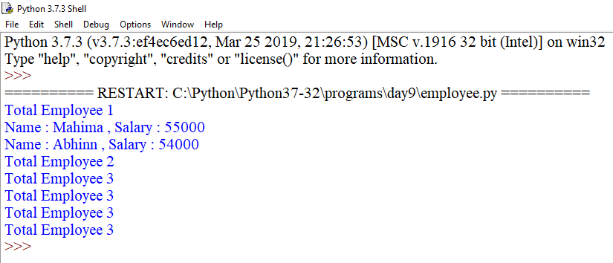

class Employee:

empCount=0

def __init__(self,name,salary):

self.name=name

self.salary=salary

Employee.empCount+=1

def displayCount(self):

print("Total Employee %d"% Employee.empCount)

def displayEmployee(self):

print("Name :",self.name,", Salary :",self.salary)

emp1=Employee("Nikhil",9999)

emp1.displayEmployee()

emp1.salary=17000

emp1.experience=3

emp1.displayEmployee()

emp1.name="Manoj"

emp1.displayEmployee()

print(emp1.experience)

#del emp1.salary

emp1.displayEmployee()

**OUTPUT**

